

**SCHOOL OF COMPUTER SCIENCES**

**Academic Session 2019/2020, Semester 2**

**CPT 115 (Mathematical Methods for Computer Science)**

**Dr. Pantea Keikhosrokiani**

**ASSIGNMENT 2**

**Title: Data collection, analysis, and interpretation.**

**(Data collection, calculation, descriptive analysis and displaying data, regression analysis and hypotheses testing)**

**Due date: Monday, 15th June 2020**

**Group Members:**

|  |  |  |
| --- | --- | --- |
| **NO.** | **FULL NAME** | **STUDENT’S MATRIC NO.** |
| 1 | TAKI EDDINE TORKI |  |
| 2 | WONG CHONG YANG |  |
| 3 | NURUL FASIHAH BINTI ABD RAZAK |  |
| 4 | WAN ATIFAH NUR ALIA |  |
| 5 | NOR ISLAHIAH BINTI MUHAMMED | 149891 |

**PART I - Data collection**

Please refer “Sheet1” in “File for data collection.xlsx”.

**PART II - Calculation**

a. Create frequency table and calculate relative frequency for your dataset.

| **Calories per day (x)** | **Tally** | **Frequency (f)** | **Relative frequency (rf)** |
| --- | --- | --- | --- |
| 352 | / | 1 | 1/35=0.0285714285714286 |
| 652 | / | 1 | 1/35=0.0285714285714286 |
| 880 | / | 1 | 1/35=0.0285714285714286 |
| 934 | / | 1 | 1/35=0.0285714285714286 |
| 940 | // | 2 | 2/35=0.0571428571428571 |
| 980 | / | 1 | 1/35=0.0285714285714286 |
| 984 | / | 1 | 1/35=0.0285714285714286 |
| 1020 | / | 1 | 1/35=0.0285714285714286 |
| 1044 | / | 1 | 1/35=0.0285714285714286 |
| 1060 | / | 1 | 1/35=0.0285714285714286 |
| 1095 | / | 1 | 1/35=0.0285714285714286 |
| 1170.5 | / | 1 | 1/35=0.0285714285714286 |
| 1196 | / | 1 | 1/35=0.0285714285714286 |
| 1205 | / | 1 | 1/35=0.0285714285714286 |
| 1210 | / | 1 | 1/35=0.0285714285714286 |
| 1221.5 | / | 1 | 1/35=0.0285714285714286 |
| 1249 | / | 1 | 1/35=0.0285714285714286 |
| 1294 | / | 1 | 1/35=0.0285714285714286 |
| 1310 | / | 1 | 1/35=0.0285714285714286 |
| 1333 | / | 1 | 1/35=0.0285714285714286 |
| 1359 | / | 1 | 1/35=0.0285714285714286 |
| 1368 | / | 1 | 1/35=0.0285714285714286 |
| 1381 | // | 2 | 2/35=0.0571428571428571 |
| 1390 | /// | 3 | 3/35=0.0857142857142857 |
| 1417 | / | 1 | 1/35=0.0285714285714286 |
| 1483 | / | 1 | 1/35=0.0285714285714286 |
| 1611 | / | 1 | 1/35=0.0285714285714286 |
| 1627.5 | / | 1 | 1/35=0.0285714285714286 |
| 1651 | / | 1 | 1/35=0.0285714285714286 |
| 1701 | / | 1 | 1/35=0.0285714285714286 |
| 2456 | / | 1 | 1/35=0.0285714285714286 |

Total of frequency = 35

Relative frequency (rf) = Frequency (f) / Total of frequency

b. Calculate the minimum, maximum, mean, and mode values for your collected dataset.

Minimum

= The lowest value in the dataset (x)

= 352

Maximum

= The highest value in the dataset (x)

= 2456

Mean

* Please refer the next page

Mode:

= The most frequent value in the dataset (x)

= 1390 (frequency: 3)

Mean ( )

= The average value inside the dataset (x)

= Sum of observations / Number of observations

= ∑xf / ∑n or ∑xf / ∑f

= Total of product (xf) / Total frequency

= 43675.5/35

= 1247.87

|  |  |  |  |
| --- | --- | --- | --- |
| **Calories per day (x)** | **Tally** | **Frequency (f)** | **Product (x.f)** |
| 352 | / | 1 | 352x1=352 |
| 652 | / | 1 | 652x1=652 |
| 880 | / | 1 | 880x1=880 |
| 934 | / | 1 | 934x1=934 |
| 940 | // | 2 | 940x2=1880 |
| 980 | / | 1 | 980x1=980 |
| 984 | / | 1 | 984x1=984 |
| 1020 | / | 1 | 1020x1=1020 |
| 1044 | / | 1 | 1044x1=1044 |
| 1060 | / | 1 | 1060x1=1060 |
| 1095 | / | 1 | 1095x1=1095 |
| 1170.5 | / | 1 | 1170.5x1=1170.5 |
| 1196 | / | 1 | 1196x1=1196 |
| 1205 | / | 1 | 1205x1=1205 |
| 1210 | / | 1 | 1210x1=1210 |
| 1221.5 | / | 1 | 1221.5x1=1221.5 |
| 1249 | / | 1 | 1249x1=1249 |
| 1294 | / | 1 | 1294x1=1294 |
| 1310 | / | 1 | 1310x1=1310 |
| 1333 | / | 1 | 1333x1=1333 |
| 1359 | / | 1 | 1359x1=1359 |
| 1368 | / | 1 | 1368x1=1368 |
| 1381 | // | 2 | 1381x2=2762 |
| 1390 | /// | 3 | 1390x3=4170 |
| 1417 | / | 1 | 1417x1=1417 |
| 1483 | / | 1 | 1483x1=1483 |
| 1611 | / | 1 | 1611x1=1611 |
| 1627.5 | / | 1 | 1627.5x1=1627.5 |
| 1651 | / | 1 | 1651x1=1651 |
| 1701 | / | 1 | 1701x1=1701 |
| 2456 | / | 1 | 2456x1=2456 |

Total of frequency (f) = 35

Total of product (xf) = 43675.5

c. Calculate standard deviation and variance for your collected dataset.



Standard deviation ( )

=

=

= 346.85

Variance

= the average of the square of the difference in value of a datum from the mean

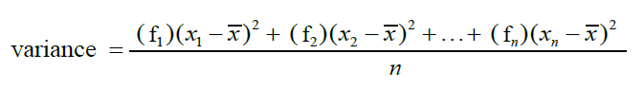

=

= Total of [(frequency of the datum)(the square of datum - mean)] / Total of frequency

* Please refer the next page for calculation table

= 4210592.17 / 35

= 120302.63

|  |  |  |  |  |  |
| --- | --- | --- | --- | --- | --- |
| **Calories**  **per day**  **(x)** | **Tally** | **Frequency (f)** | **x - mean (1247.87)** | **(x - mean)^2** | **((x - mean)^2)*f** |
| 352 | / | 1 | -895.87 | 802583.06 | 802583.06 |
| 652 | / | 1 | -595.87 | 355061.06 | 355061.06 |
| 880 | / | 1 | -367.87 | 135328.34 | 135328.34 |
| 934 | / | 1 | -313.87 | 98514.38 | 98514.38 |
| 940 | // | 2 | -307.87 | 94783.94 | 189567.87 |
| 980 | / | 1 | -267.87 | 71754.34 | 71754.34 |
| 984 | / | 1 | -263.87 | 69627.38 | 69627.38 |
| 1020 | / | 1 | -227.87 | 51924.74 | 51924.74 |
| 1044 | / | 1 | -203.87 | 41562.98 | 41562.98 |
| 1060 | / | 1 | -187.87 | 35295.14 | 35295.14 |
| 1095 | / | 1 | -152.87 | 23369.24 | 23369.24 |
| 1170.5 | / | 1 | -77.37 | 5986.12 | 5986.12 |
| 1196 | / | 1 | -51.87 | 2690.50 | 2690.50 |
| 1205 | / | 1 | -42.87 | 1837.84 | 1837.84 |
| 1210 | / | 1 | -37.87 | 1434.14 | 1434.14 |
| 1221.5 | / | 1 | -26.37 | 695.38 | 695.38 |
| 1249 | / | 1 | 1.13 | 1.28 | 1.28 |
| 1294 | / | 1 | 46.13 | 2127.98 | 2127.98 |
| 1310 | / | 1 | 62.13 | 3860.14 | 3860.14 |
| 1333 | / | 1 | 85.13 | 7247.12 | 7247.12 |
| 1359 | / | 1 | 111.13 | 12349.88 | 12349.88 |
| 1368 | / | 1 | 120.13 | 14431.22 | 14431.22 |
| 1381 | // | 2 | 133.13 | 17723.60 | 35447.19 |
| 1390 | /// | 3 | 142.13 | 20200.94 | 60602.81 |
| 1417 | / | 1 | 169.13 | 28604.96 | 28604.96 |
| 1483 | / | 1 | 235.13 | 55286.12 | 55286.12 |
| 1611 | / | 1 | 363.13 | 131863.40 | 131863.40 |
| 1627.5 | / | 1 | 379.63 | 144118.94 | 144118.94 |
| 1651 | / | 1 | 403.13 | 162513.80 | 162513.80 |
| 1701 | / | 1 | 453.13 | 205326.80 | 205326.80 |
| 2456 | / | 1 | 1208.13 | 1459578.10 | 1459578.10 |

Total of frequency (f) = 35

Total of [(frequency of the datum)(the square of datum - mean)] = 4210592.17

**PART III - Descriptive analysis & Displaying Data**

**PSEUDOCODES**

1. Start
2. Import modules numpy as np
3. Import function mode from modules statistics
4. Import modules matplotlib.plyplot as plt
5. Define and initialize array variable for self-reported total calories intake as calories
6. Find the maximum value of the array (calories)
7. Display the maximum value
8. Find the minimum value of the array (calories)
9. Display the minimum value
10. Find the mode value of the array (calories) using statistics module
11. Display the mode value using statistics module
12. Find the frequency of the mode value of the array (calories) using statistics module
13. Display the frequency of the mode value using statistics module
14. Calculate the mean value of the array (calories) using numpy module
15. Display the mean value using numpy module
16. Calculate the variance value of the array (calories) using numpy module
17. Display the variance value using numpy module
18. Calculate the standard deviation value of the array (calories) using numpy module
19. Display the standard deviation value using numpy module
20. Set up boxplot based on the array (calories) using matplotlib.plyplot module
21. Display the boxplot using matplotlib.plyplot module
22. Set up histogram based on the array (calories) using matplotlib.plyplot module
23. Display the histogram using matplotlib.plyplot module
24. End

**FLOWCHART**

Import required modules (numpy, statistics, matplotlib.plyplot)

Define and initialize array variable for self-reported total calories intake (calories)

Find and display the maximum value of the array (calories)

Find and display the minimum value of the array (calories)

Find and display the mode value of the array (calories) using statistics module

Find and display the frequency of the mode value of the array (calories)

using statistics module

Calculate and display the mean value of the array (calories) using numpy module

Calculate and display the variance value of the array (calories) using numpy module

Calculate and display the standard deviation value of the array (calories)

using numpy module

Set up and display boxplot based on the array (calories) using matplotlib.plyplot module

Set up and display histogram based on the array (calories)

using matplotlib.plyplot module

**CODES**

#import the required modules

import numpy as np

from statistics import mode

import matplotlib.pyplot as plt

calories = [1417, 1611, 1483, 1651, 1333, 1368, 1359, #CY

1390, 1381, 652, 1390, 352, 1381, 1390, #Taki

1060, 1205 ,1210 ,1020, 940, 880, 940, #Fasihah

1701,1170.5,1627.5,2456,1221.5,1294,1044, #Islahiah

934, 1095, 1196, 1310, 980, 984, 1249] #Atifah

print("Maximum calories intake:",max(calories))

print("\nMinimum calories intake:",min(calories))

print("\nMode calories intake:", mode(calories))

print("\nFrequency of mode:",calories.count(mode(calories)))

print("\nMean calories intake:", np.mean(calories))

print("\nVariance:",np.var(calories))

print("\nStandard deviation:",np.std(calories))

plt.title('Boxplot for calories intake')

plt.boxplot(calories)

plt.show()

plt.title('Histogram for calories intake')

plt.hist(calories)

plt.show()

**RESULT**

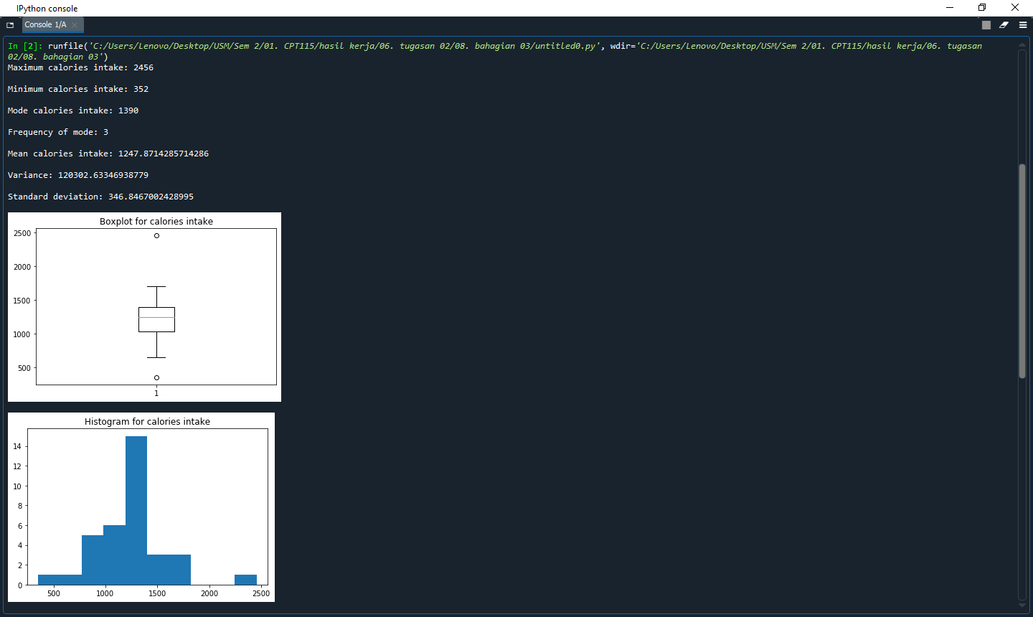

**PART IV - Regression Analysis**

**PART V - Hypotheses testing**

**PART VI - Conclusion**